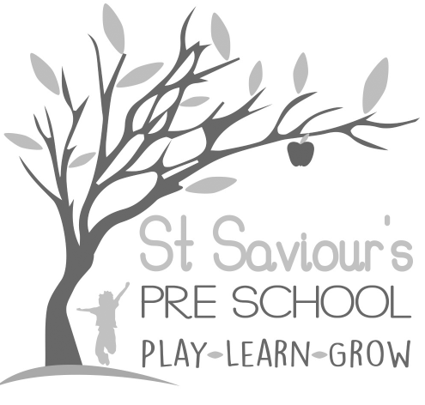
8.0 SAFETY AND SUITABILITY OF PREMISES, ENVIRONMENT AND EQUIPMENT

8.1 HEALTH AND SAFETY GENERAL STANDARD

Written by: Claire Toms and Tina Alder Date: 1.09.22. – reviewed 08.10.24.

Policy Statement
We believe that the health, safety, and well-being of children, staff, parents, and visitors is of paramount importance. We aim to create a safe and healthy environment where children can thrive and learn.
- We raise awareness of health and safety issues with children, parents, staff, and volunteers.
- Tina Alder is the designated Health and Safety Lead, trained and responsible for ensuring compliance and regular updates to her knowledge.
- Health and safety procedures are displayed on the Kitchen notice board and in the Emergency Box.

Insurance Cover
- We maintain Public Liability and Employer’s Liability Insurance. Certificates are displayed in the hall.

Procedures

Awareness Raising
- Health and safety induction for all staff and volunteers is mandatory, covering safe working practices, storage of hazardous materials, lifting, and employee well-being.
- We operate a strict no-smoking policy across the premises.
- Children are taught about health and safety through age-appropriate discussions, routines, and activities.

Hall and Rainbow Room
- Doors to the church porch and outside areas are locked and alarmed; checked daily.
- Visitors sign in/out in the Visitors Book in the emergency box.
- Registers, keys, and phones are kept in the Emergency Box at the front desk.
- Fire doors are kept closed and unobstructed.
- Hot drinks and potentially dangerous items are kept out of children’s reach.
- Staff maintain ratios and inform colleagues before leaving an area.
- Floors are checked daily for cleanliness, wetness, or damage; spills are cleaned immediately.

Kitchen
- Children do not have unsupervised access to the kitchen.
- Kettle leads and electrical items are kept safe and out of reach.
- Floors are checked for wetness; warning signs are used if needed.
- Doors are kept closed while children are present.
- Cooking and preparation activities are supervised at all times.

Toilets
- Toilets and high-touch areas (door handles, light switches) are cleaned before, during, and after sessions.
- Hygiene supplies (soap, paper towels, disinfectant, gloves) are available and replenished regularly.
- Children are reminded to wash hands for 20 seconds after using the toilet.
- Gloves and aprons are worn when dealing with bodily fluids.

Outdoor Play
- Outdoor areas are securely fenced, padlocked, and checked for hazards before use.
- Staff ensure children are dressed appropriately for weather and activities.
- Sun protection: parents provide named hats and apply sunscreen before sessions.
- Two staff are present outside at all times; additional staff required for multiple groups.
- Climbing equipment is supervised closely within key groups.
- Children are taught not to pick or eat plants, berries, or seeds.

Hard Surface Play
- Gates and sheds are secured.
- Children are supervised in line with EYFS ratios.

Equipment
- All new equipment must have a BSI Kite Mark or equivalent.
- Equipment is checked before use; damaged items are removed for repair or disposal.
- Materials, including paints and glue, are non-toxic.
- Physical play is constantly supervised.
- Children are taught safe handling and storage of tools.

Electrical Equipment
- All electrical equipment conforms to safety standards.
- Hot water sources are inaccessible to children; hot water temperature is controlled to prevent scalds.
- Electrical devices are switched off at the plug after use.
- Adequate lighting and ventilation are maintained.

Storage
- All resources are stored safely to prevent falling or injury.
- Large equipment is stored and moved using safe procedures, and staff have access to safe equipment to reach high storage.

Hazardous Materials
- Chemicals are stored in original containers, out of reach of children, and only used when necessary.
- Staff use chemicals safely and are vigilant at all times.

Jewellery and Accessories
- Staff do not wear jewellery or accessories that pose a safety risk.
- Children’s jewellery must not be a choking or strangulation hazard.

Supervision & Risk Assessment (EYFS 2025 Updates)
- Continuous supervision is maintained in line with EYFS 2025 ratios.
- Daily risk assessments are carried out for indoor and outdoor spaces, activities, equipment, and outings.
- Records of any hazards or incidents are logged and acted upon.
- Staff are trained to identify risks proactively and take immediate action to mitigate them.

